Tool 2: Authorizer Website Guidance
As an authorizer, making information about current and prospective charter schools publicly available is essential for accountability and transparency. Furthermore, the PA School Code makes clear that it is the responsibility of authorizers under the “Sunshine Act” to provide notice of school board activities related to charter application and renewal decisions.
Authorizers should maintain an up-to-date section of their website that contains the following information:
- New charter application information and timeline
- New charter applications received
- New charter application decisions
- Charter school annual reports
- Annual review findings, if appropriate
- Charter renewal notice of hearings and findings
- Complaint procedure
- Model student application and enrollment forms
When setting up a charter school section on the district’s website, consider the audience of each subpage, as different information will be relevant to different groups. Some authorizers choose to divide their site into sections that provide information for families, such as policies and school reports, and charter operators, which may include reporting requirements and application information. Because many families may not have access to computers, websites should also be accessible by mobile phones.
Screenshot of the homepage of the charter school section of the Pittsburgh Public Schools website:
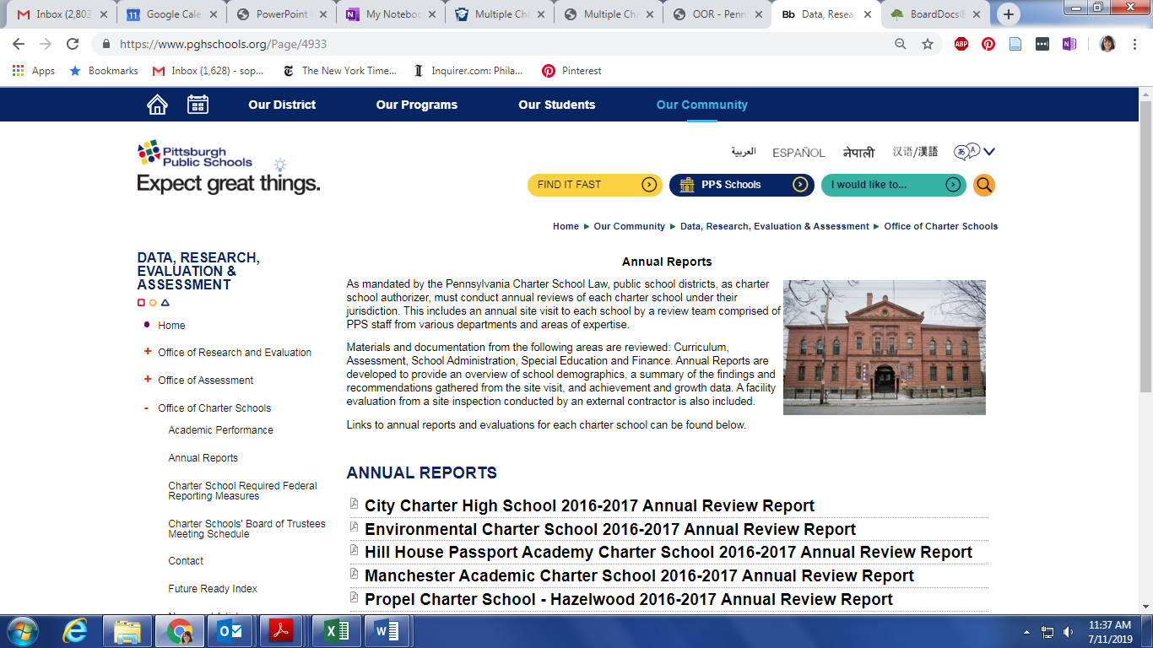

Pennsylvania General Assembly. Title 65 of 1998 (65 Pa.C.S. §§ 701-716). Retrieved from https://www.legis.state.pa.us/cfdocs/legis/LI/consCheck.cfm?txtType=HTM&ttl=65&div=0&chpt=7

